Lecture notes:
Causal Inference using Machine Learning for Agricultural Policy Making
Maxwell Mkondiwa, PhD
International Maize and Wheat Improvement Center (CIMMYT)
Email: m.mkondiwa@cgiar.org

Summary
This course module provides a primer to causal inference using machine learning for agricultural policy makings. The causal machine learning (Causal ML) toolkit allows targeting of agricultural interventions to locations and farmers. This allows heterogeneous effects analysis and “personalized” policy targeting. I will focus more on applications in the agricultural sector especially in developing countries.

1. Introduction
The tradition of agricultural statistics and the design of experiments which was started by R.A. Fisher has helped in the development of better agricultural production practices. These were aimed at establishing the cause and effect of a specific agricultural practice. In recent years, due to the increased availability of data and the efficiency of computers, machine learning approaches have been advanced that assure better prediction. Breiman (2001) called the causal inference tradition of R.A. Fisher and prediction approaches the “Two cultures” of statistical modeling. In recent years, a growing literature has proposed a third culture called causal machine learning which integrates the best of Breiman’s two cultures. Parallel to the causal machine learning paradigm is the knowledge guided machine learning (KGML) (e.g., Liu et al 2022) which integrates mechanistic models and machine learning models. For economists, you may consider the “knowledge” or “causal” part as derived from economic theory (e.g., demand and supply), behavior and real-world mechanisms. It is what Bruce Gardner (Gardner 1992, AAEA fellow’s lecture) called “Factology” to warn that data are not facts. This is the basic ingredient for applying machine learning algorithms.
These three cultures, however, just provide an assessment of the technological gains but do not provide decisions on what is best for that farmer or for society. Decision support tools and recommender systems are usually then used to guide farmers in taking the best choices. These can be simple like yield maximization, profit maximization, and risk minimization. Finally, there are tools that consider the complexity of the systems and the interrelatedness of farmer decisions, their environment, and trade mostly studied using system optimization models. We argue that this framework (figure 2) can be implemented in one integrated workflow of causal AI or knowledge guided machine learning (KGML) thereby propagating model uncertainty from causal inference, predictive, decision support and system optimization models.
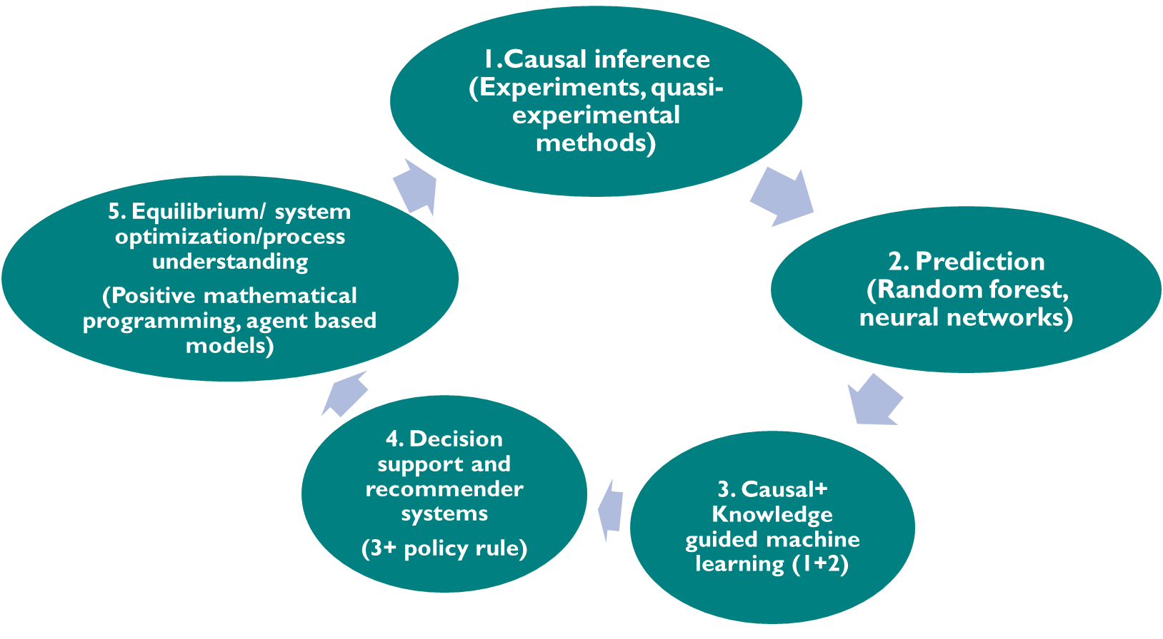
Figure 1: The five cultures in agricultural big data analytics for policy making. Source: Mkondiwa et al (2023).

Learning objectives
By the end of the lecture, participants should be able:
- To understand the advantages and disadvantages of using causal machine learning
- To explore potential applications that learners can implement using various causal machine learning methods.
- To learn how to code the building blocks of a causal machine learning application using readily available data.

Course contents
- Why machine learning and causal inference in agricultural policy making? Merits and demerits
- Theoretical rules of thumbs for causal machine learning
- Applications of causal machine learning for agricultural policy analysis
- Hands on training: Using causal machine learning in groups
- Group discussion on potential topics and data: Follow up plan on working on those papers
- Hybrid applications of causal machine learning with other agricultural policy analysis tools: Causal ML+ Economic Surplus Analysis, Causal ML+ Mathematical Programming Agricultural Sector Models.

Course materials
All readings and code for this module are available on GitHub: https://github.com/MaxwellMkondiwa/Training_Materials/tree/main/2026/NIAP.

2. Causal machine learning methods
There are many causal machine learning methods. For every machine learning algorithm, there are corresponding causal inference variations.
For example, (causal) random forest, (double) LASSO, e.t.c. We will focus on causal random forest. It is simple and commonly used among agricultural economists.
See slides for derivations

3. Case studies of causal machine learning as applied to agricultural policy questions

Impact assessments of resource conserving agricultural technologies

Heterogenous impact of crop rotations on yields
Examples: Kluger et al (2022, 2026) for USA, France, Canada and China. Takeshima and Kishore (2026) for India
Purpose: Crop rotations are proposed as potential yield increasing and risk reduction technologies. Experimentally, agronomists randomize the rotations and across several years assess the impacts. In real world settings, it is difficult to assess because there are too many rotations (in some cases), each with many input use combinations and that farmers’ choices of what to do in each of the crops in the sequence is not random. The two case studies address these challenges.
Data and variables: Kluger et al (2026) uses earth observation data on crop type maps, monthly precipitation, monthly maximum temperature averages and monthly vapor pressure deficit. Output proxied by green chlorophyll vegetation index (GCVI).
Causal identification strategy:

What causal ML contributed to the analysis:
See slides for detailed results

Replication materials: R code for rotation studies: (https://zenodo.org/records/15579276) and Zhou et al (2024) (t https://doi.org/10.5281/zenodo.13901372). Cover crops study (Deines et al 2022) code: https://doi.org/10.5281/zenodo.7199708

Impact of tillage practices on yield, incomes and emissions
Examples: Deines et al (2019)

Replication materials: https://zenodo.org/records/3525346 and https://zenodo.org/records/3525359.

Climate change impact and adaptation options prioritization
Examples: Mkondiwa et al 2025 on heterogenous impacts of droughts on rice crop management and yields in Bihar, #### on zero tillage in USA and conservation practices in Europe (Stetter)

Replication materials:

Fertilizer targeting applications (mostly in Africa)
Examples: McCullough et al (2022) Nature Food, Mkondiwa et al (2024)
Purpose:
Spatially explicit economic surplus impacts of targeted fertilizer application in Tanzania

Replication materials:

Impact assessment of government interventions and schemes
Examples: Stetter et al (2022), Esposti (2024)

4. Causal Random Forest Workflow [hands on]

5. Hybrid causal AI and other agricultural policy analysis tools

Causal random forest + economic surplus modelling

Causal ML + mathematical programming models for agricultural sector

Causal ML+ spatial risk assessments

Recommended reading materials
Mkondiwa et al (2024), Athey (2025), Wager (2025) and Chernukokhev (2025).

Software
R: grf package
Python:

Acknowledgements
I acknowledge the funding support from CSISA, CSISA Scoping Grant, and Sustainable Farming program of the CGIAR funded by Gates Foundation. All errors are mine.

References
Athey
Deines, J.M., Wang, S., Lobell, D.B. 2019. “Satellites reveal a small positive yield effect from conservation tillage across the US Corn Belt”. Environmental Research Letters 14: 124038. Doi: 10.1088/1748-9326/ab503b.
Gardner, B.L. 1992. “How the data we make can unmake us: Annals of factology”. American Journal of Agricultural Economics 74 (5): 1066-1075. Doi: https://doi.org/10.2307/1242760.
Kluger, D.M., Owen, A.B., and Lobell, D.B. 2022. “Combining randomized field experiments with observational satellite data to assess the benefits of crop rotations on yields”. Environmental Research Letters 17: 044066. Doi: 10.1088/1748-9326/ac6083.
Kluger, D.M., Tommaso, S.D., and Lobell, D.B. 2025. “Precrop payoffs: causal machine learning reveals large but variable yield benefits of crop rotation in major breadbaskets”.

Stetter, C., Mennig, P., and Sauer, J. 2022. “Using machine learning to identify heterogeneous impacts of agri-environment schemes in the EU: A case study”

Takeshima, H., and Kishore, A. 2026. “Estimating cumulative input effects in annual crop production: A LASSO-based panel data approach from India”. Agricultural Systems 231: 104555. Doi: https://doi.org/10.1016/j.agsy.2025.104555.

Zhou, J., Zhu, P., Kluger, D.M., Lobell, D.B., and Jin, Z. 2024. “Changes in the yield effect of the preceding crop in the US corn belt under a warming climate”. Global Change Biology 30 (11): e17556. Doi: https://doi.org/10.1111/gcb.17556.
Mkondiwa, M., Kumar, V., Craufurd, P., McDonald, A., and Malik, R. 2023. “Empowering sustainability transitions in agri-food systems using big data and causal artificial intelligence”. Conference lead paper. Url: https://www.researchgate.net/profile/Maxwell-Mkondiwa/publication/380290487_Empowering_Sustainability_Transitions_in_Agri-food_Systems_Using_Big_Data_and_Causal_Artificial_Intelligence_Causal_AI/links/6633c73a06ea3d0b74237814/Empowering-Sustainability-Transitions-in-Agri-food-Systems-Using-Big-Data-and-Causal-Artificial-Intelligence-Causal-AI.pdf.
Mkondiwa, M…. 2025. Farmers agronomic management responses to extreme drought and rice yields in Bihar, India. Agricultural Water Management 320: 109830. Doi: https://doi.org/10.1016/j.agwat.2025.109830.
Mkondiwa, M., & Chamberlin, J. (2024). Spatially explicit trends in nitrogen use efficiency and partial profits in Tanzania, 2008-2020. EIA. https://hdl.handle.net/10883/35304.

